Music All Over

Project Description:

1. Overview: the project is about combining Spotify and Google Map to analyze the preference of the type of music of people in different regions.
2. Motivation: I personally love to listen to music. However, whenever I go to a new place and meet new people. I found that people from different region and age have different preference of type of music. Therefore, I have the inspiration to build Magic All Over, to combine people’s preference of the type of music and their location on Google Map. In order to analyze the relation between region and the preference of the type of music being listened. According to the result, the music producers (including singers, composers, lyricist and so on, basically include every person in the music scene) could have a clarify tendency of the group they aim for. Therefore, they can produce more music that matches the demand of the group they aim for, and create maximum efficiency.

Project Planning:

I will be combining Spotify and Google Map, by analyzing the tendency of music the users from different ages and regions listen to and then point it out on Google Map.

1. Find the website for API:

I will find the website of the API I need. For now, it will be the API website for Spotify and the API website for Google Map. (But it Spotify is not available, I might change Spotify to KKBox, YouTube, or other music player.)

1. Obtain the API keys:

I will study the website found above and look through the Tools for Web Developers to try to get the specific API key for the information I need.

1. Analyze the data obtained from Spotify:

I plan to analyze the information obtained from Spotify. To do so, I will be aiming at high school (or even college) students. (Which is the largest group of music listeners I suppose.) Analyze which type of music they listen to the most to find their tendency of type of music.

1. Web crawl the IP of users:

Crawl the user’s IP of Spotify, and distinguish the user’s location by city. For the user’s IP, I will crawl Spotify or IPLoc.( A website which you can find the IP location of the user’s data)

1. Combine IP with Google Map:

Using the IP address received above, point out the location on Google Map. When pointing out, distinguish IP address in the unit of city. And then point out its location on Google Map, print the population of the region at the same time.

1. Combine Spotify with Google Map:

Using the pie chart acquire above, point the result on Google Map. Print the corresponding pie chart according to each location and age of listeners on Google Map.

1. Finish:

After pointing out the pie chart and population on its location, we can easily see the tendency of type of music of the listeners. Which can provide the music producers a clarify direction to aim for when composing.

Timeline:

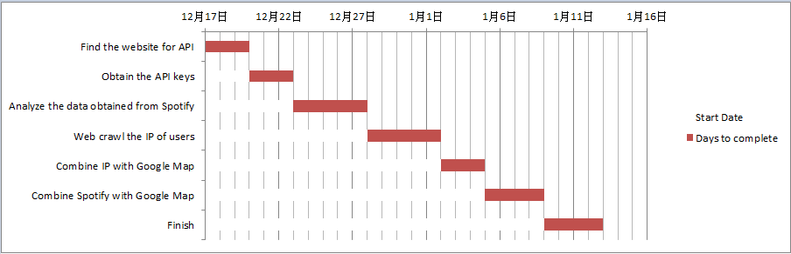

Update 1

1. What I have done:
2. I had did some research for the API that I need, and try to use them to get the data that I want. However, I am still trying to put it into my code and make use of it.
3. I web crawled the country codes (alpha-2) of all countries from Wikipedia since the web of the post office couldn’t be crawled. Therefore the web crawl part is finished. However, if time is enough, I will add another crawl for the name of the countries. Since not every people know the country code of the country they wish to search.
4. Any Changes on the final project plan, and why:
5. Change the API of data from Spotify from top list to new release:

I searched for many websites and information and found that the API for top list was available until last year, but the policy changed this year. The top list API now is only available for music producers, licensor, label, or music companies. Therefore I will change the API of the top list to the new released.

1. Change the users from person to country:

Since the data I use will change, the user type will be changing simultaneously. According to the API, it requests for country and number of the result you wish to get. Therefore, I changed the input of user from person to country to get the information I need.

1. Analyze data (album type/ pie chart):

If time is enough and the data I get is able to be analyzed, I will analyze which type of the album is. (single album, video album, live album…..)

1. Timeline for the rest:

